

**Project Report**

**PROJECT NAME** : SAURABH’S CHATBOT

**SUBMITTING TO** :

Mr. Mayur Dev Sewak  
 General Manager, Operations  
 Eisystems Services  
  
 &

Ms. Mallika Srivastava  
 Trainer, Data Science & Analytics Domain  
 Eisystems Service

**SUBMITTING BY:**

Saurabh Kumar Mishra

|  |  |  |
| --- | --- | --- |
| Serial No | Title | Page No. |
| 1 | Cover Page | 1 |
| 2 | Content table | 2 |
| 3 | List of Figures | 2 |
| 4 | Abstract of project | 3 |
| 5 | Project summary | 3 |
| 6 | Objectives of project | 4 |
| 7 | Detalis of project developed | 4-5 |
| 8 | System Requirments used | 6 |
| 9 | Data Flow Diagram | 6 |
| 10 | Input/Output Screenshots | 7-14 |
| 11 | Code/Program | 15-16 |
| 12 | References | 16 |
|  |  |  |

**Contant Table**

**List of Figures**

***Figure No: 1***

* **Caption :** Details of Project developed
* **Page No : 5**

***Figure No: 2***

* **Caption** : Data Flow Diagram
* **Page No :**

**Abstract of Project**

Project Title : Saurabh’s Chatbot

* A Chat-bot is a software application used to conduct an online chat conversation via text or text-tospeech, instead of providing direct contact with a live human agent. Designed to convincingly simulate the way a human would behave as a conversational partner.
* A chatbot allows a user to simply ask questions in the same manner that they would address a human.
* The use of chatbots evolved rapidly in numerous fields in recent years, including Marketing, Supporting Systems, Education, Health Care, Cultural Heritage, and Entertainment.

**Project Summary**

Project Title : Saurabh’s Chatbot

* Chatbot are tiny programs that help simulate interactions with customers automatically based on a set of predefined conditions , triggers, and/or events.
* There are several advantages to using All in one chatbot .
  + - * + They can be proactive and reactive.
        + Their responses are consistent every time.
        + They can respond immediately.
        + They can help you collect important data and also learn from the data collected.
        + They can be used through a variety of different mediums like sms, live chat or even social media

**Objectives Of Project**

* + - * A chatbot is a program that communicates with you.
      * Saurabh’s chatbot provides daily routine services to user.
      * Saurabh’s chatbot can access Wikipedia for accessing any article.
      * It can also access google for more information.
      * It can also make payments through phone-pe in just one click.
      * Saurabh’s chatbot can also order online food.
      * It can give weather report .
      * The main objective of All in one chatbot is to provides all services to the end user in just one click. User can explore various websites using All in one chatbot.
      * Weather forecast , social media , online food , online game ,online calculator Wikipedia ,google etc. are provided in All in one chatbot.

Details of project developed

* + It is a type of a software used to interact with humans in different languages through different mobile apps, websites, messages , etc.
  + The standard form of the bot is “Build-operate-transfer”.
  + There are seven steps to design the chatbot project. They are scope & requirement, Identify the input , understand UI elements , craft first interaction , build conversation , testing.
  + The first step to designing a chatbot is to know the scope and requirements like why chatbot platform to launch chatbots and it’s limitations.
  + The second step is to identify the inputs from users in the form of text .
  + The third step is to understand the UI elements.
  + UI elements are of five types : Command Line (CL), Graphical User Interface(GUI), Menu-Driven Interface(MDI), Form Based Interface(FBI), and Natural Language Interface(NLI).
  + After understanding user interface element, the next step is to craft the first interaction and build a conversion.
  + The final step of chatbot design process is testing , which is done on mobile and websites to know how it’s working.

Craft first interaction

Understand UI element

Scope and Requirements

Identify the input

Build Conversation

Testing

Fig. Details of Project Developed

**System Requirement Used**

* **Windows 11 Home**
* **Python 3.10**
* **Visual Studio Code**
* **Command prompt**

**Data flow Diagram / Algorithm**

START

Statement 4

ENDen

Statement just

Below if-else

ladders

Teste

Expression1

ee

estTest

Statement 3

Statement 1statement

Statement 2

Test

Expression n

Test

Expression 2

Def send():

Input Output Datasets / screenshots

* How to open All In One Chatbot :

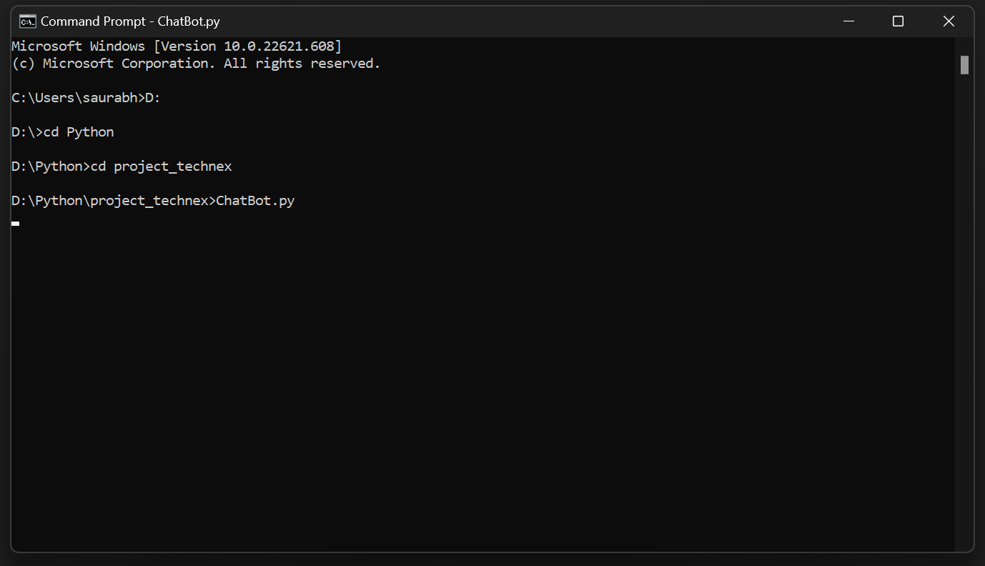

* 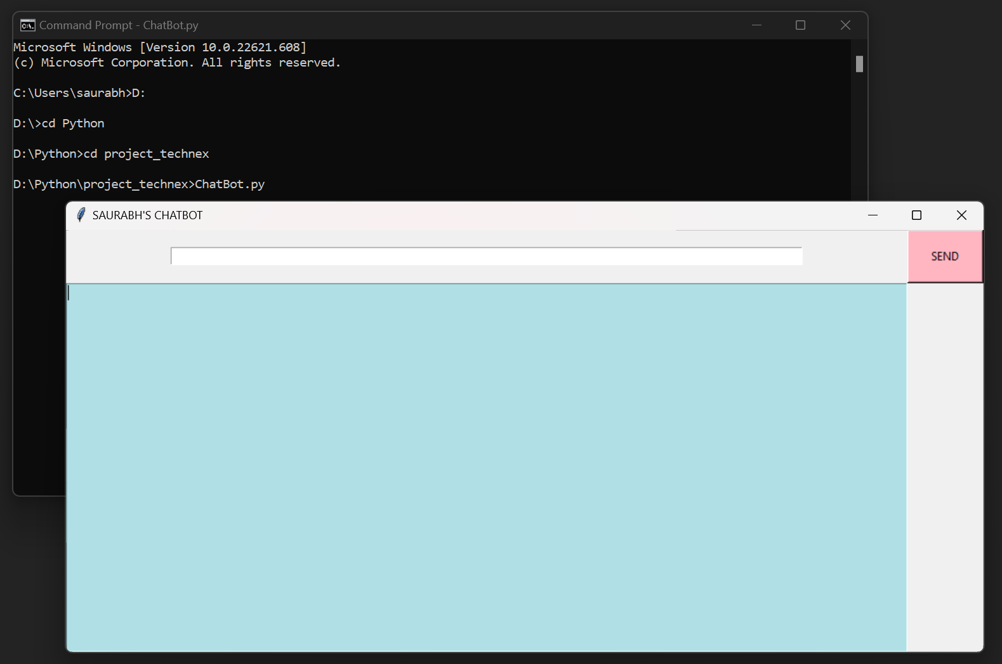Saurabh,s ChatBot :
* How to access related website using Saurabh’s ChatBot:

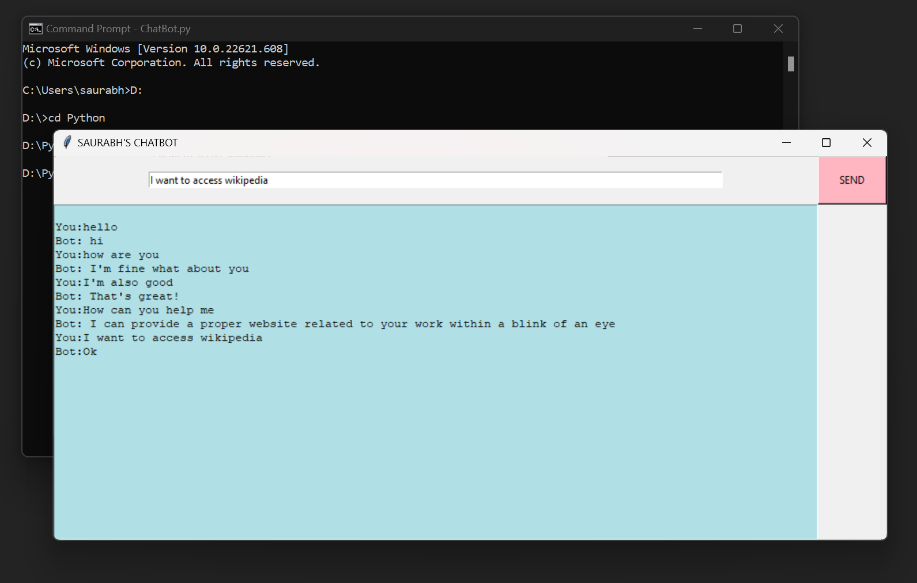

* 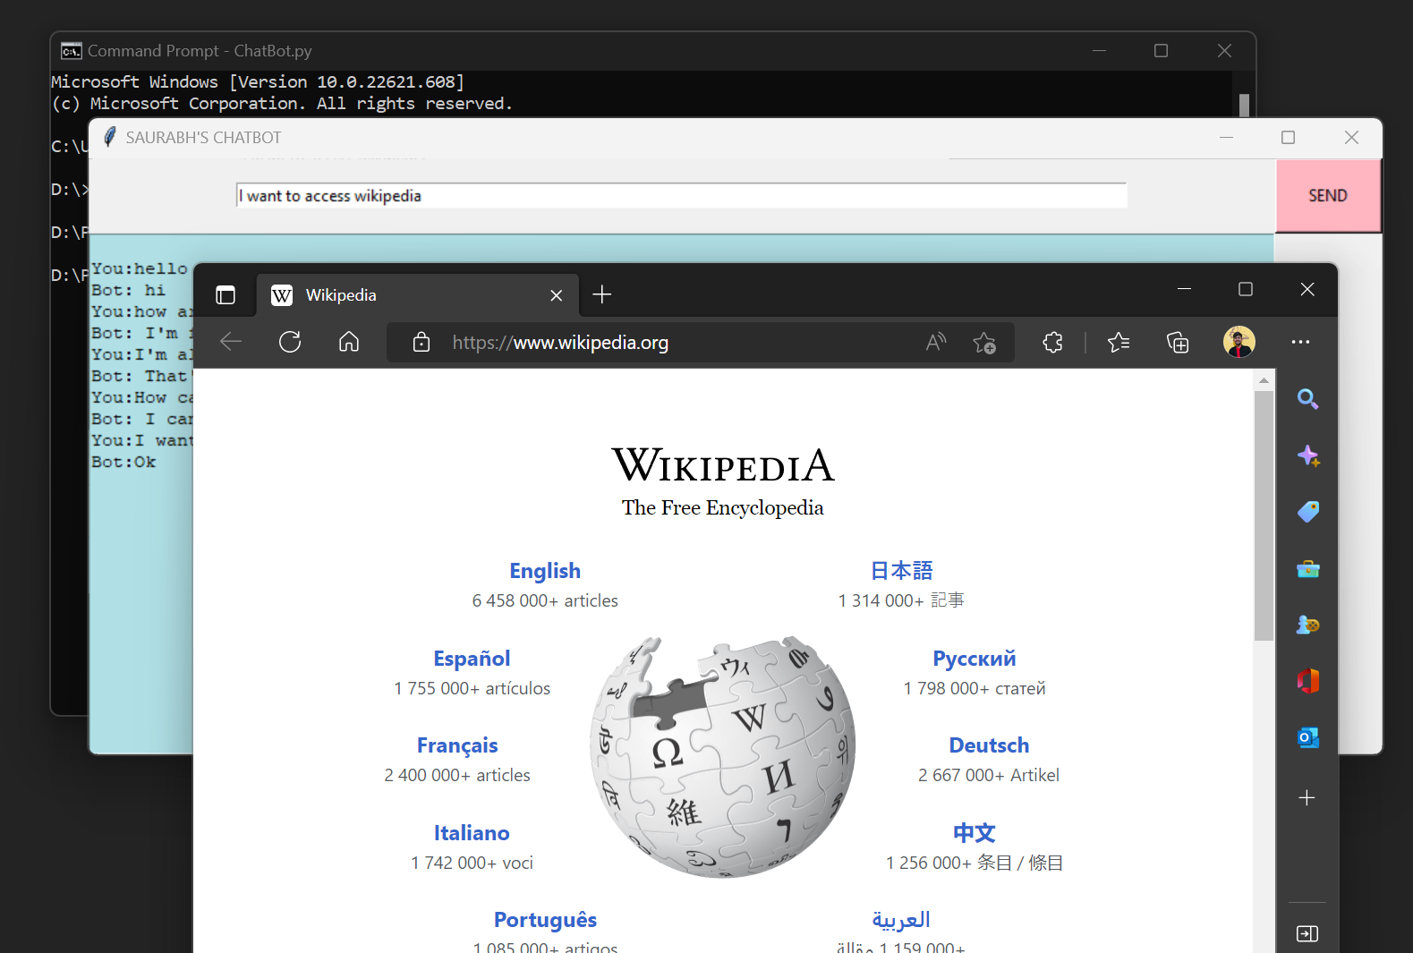Accessing wikipedia:
* 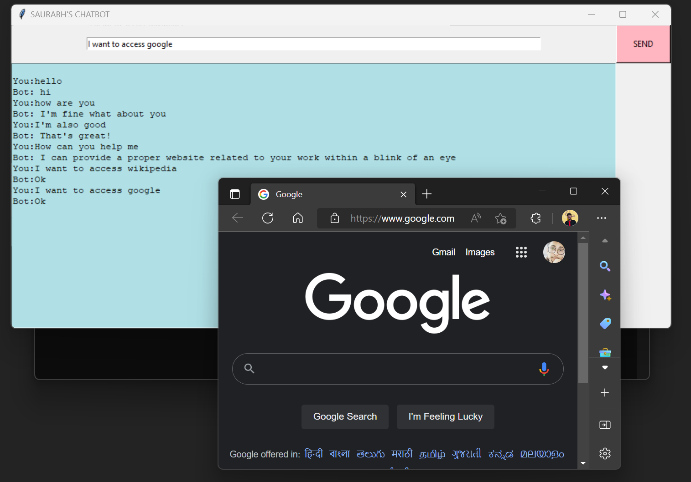Accessing Google:
* 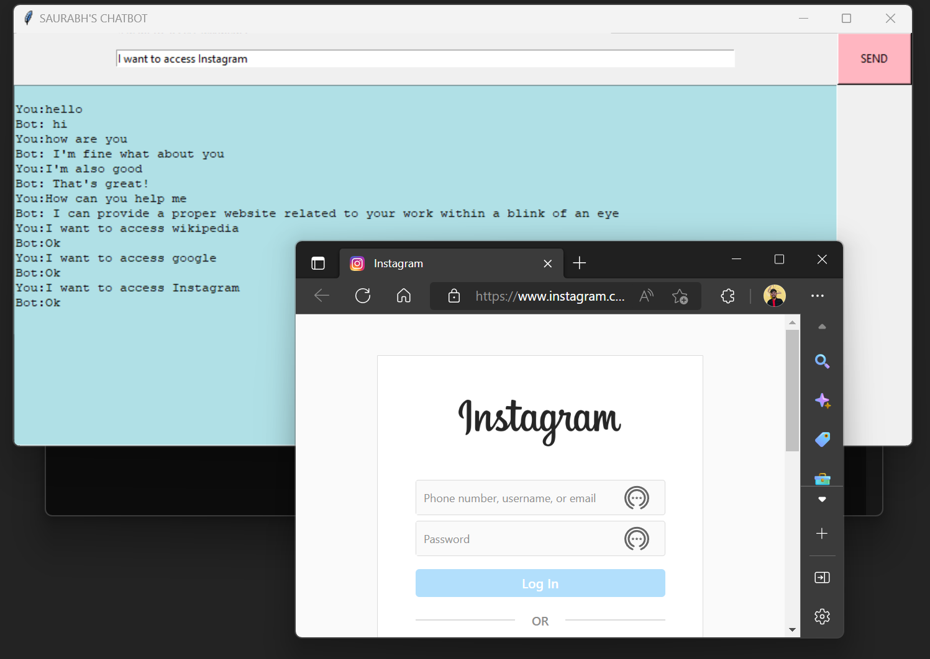Accessing Instagram:
* 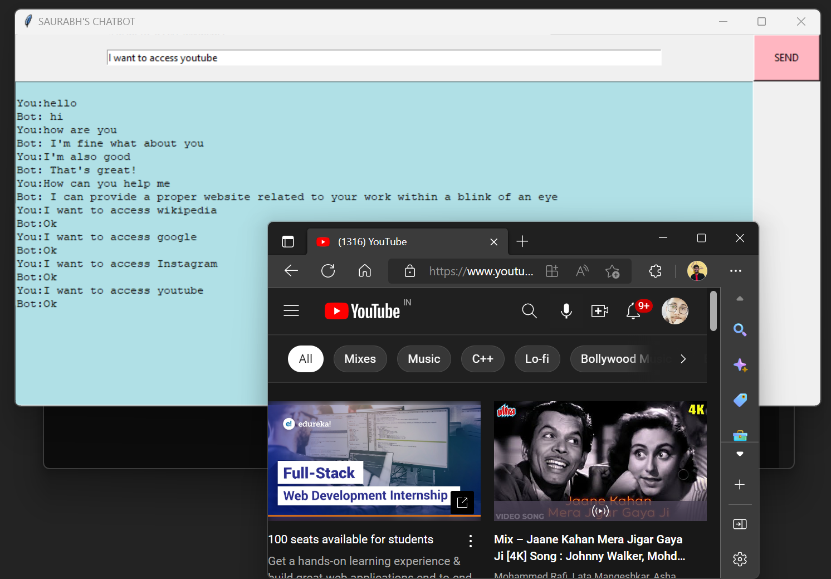Accessing Youtube:
* 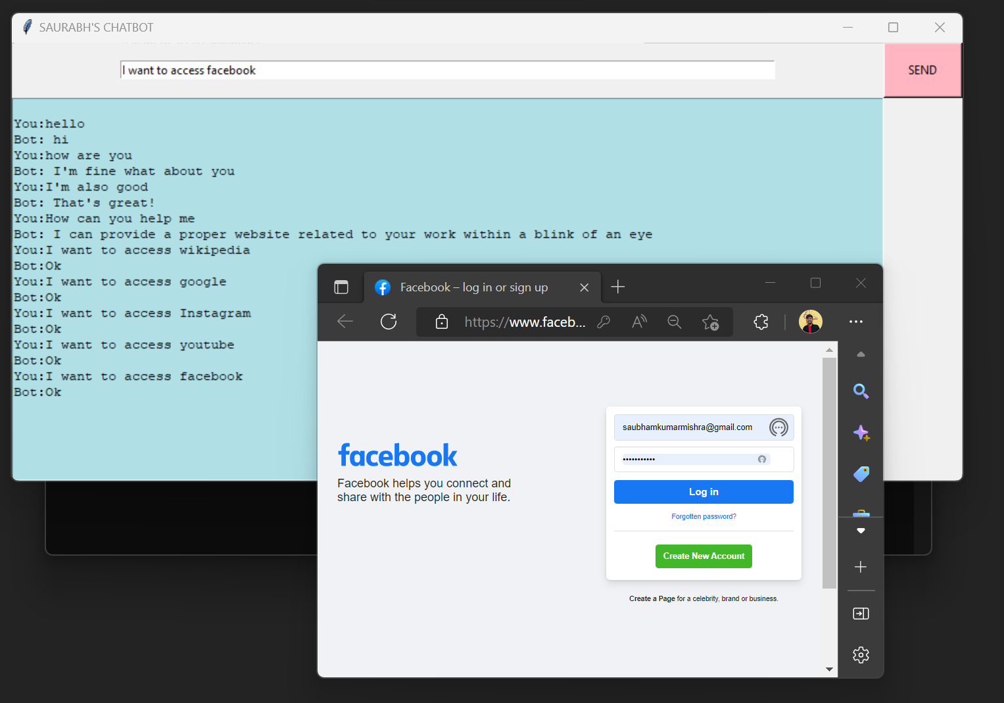Accessing Facebook
* 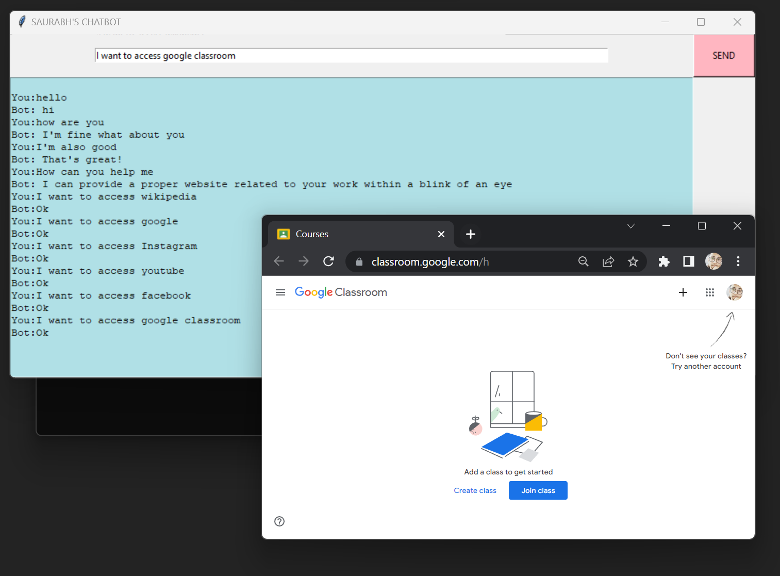Accessing Google Classroom:
* 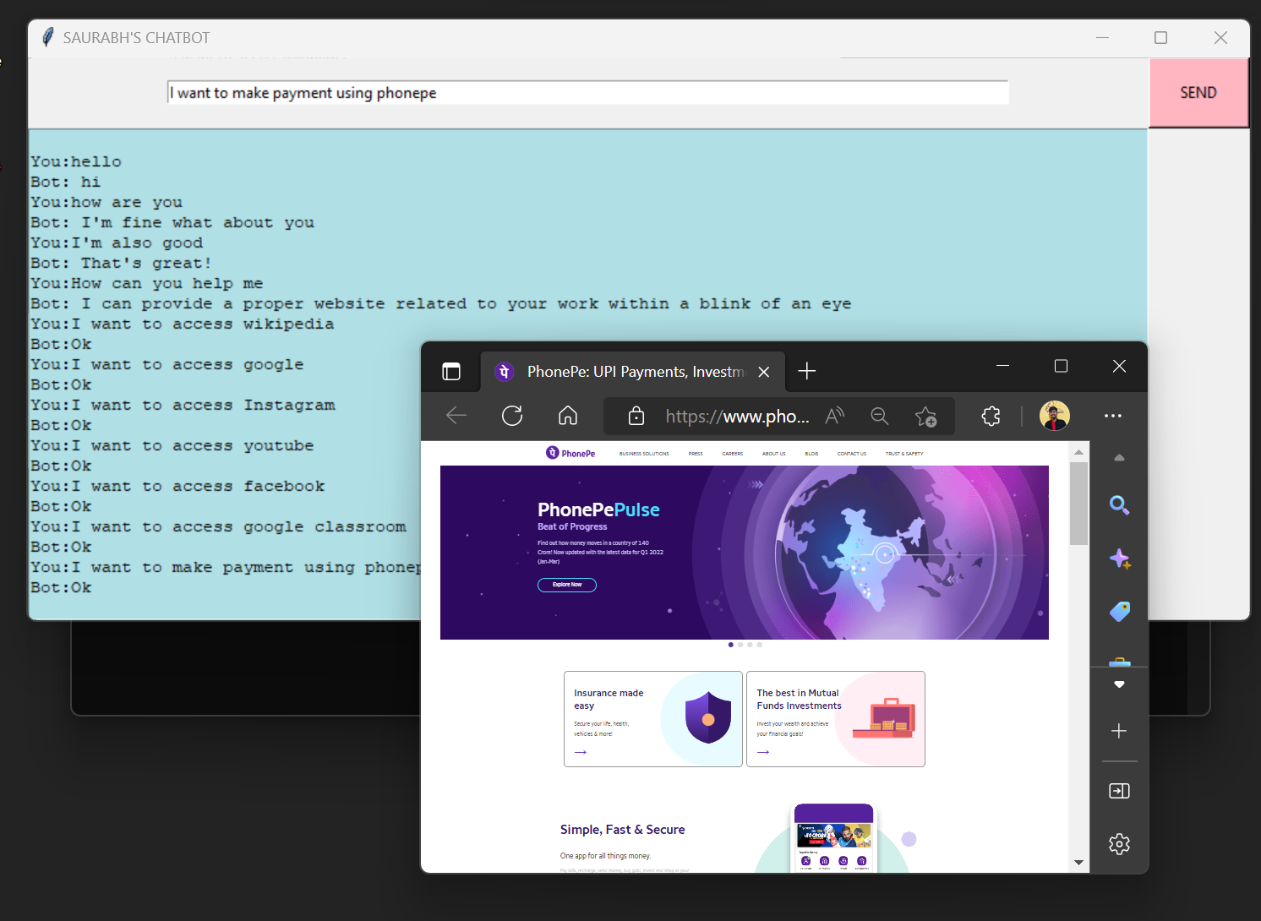 Accessing PhonePay
* 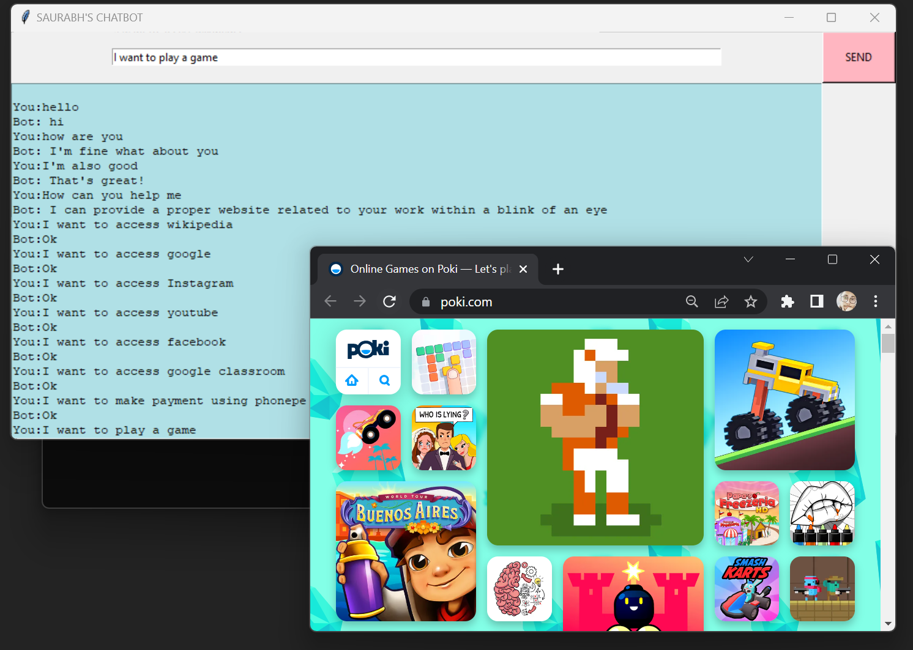Accessing Game:
* 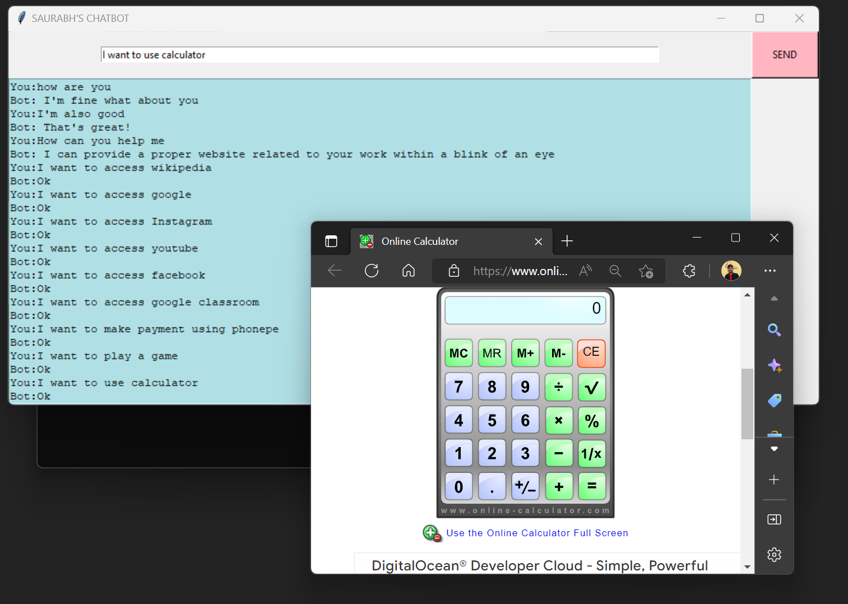Accessing Calculator:
* Online Food Ordaring:

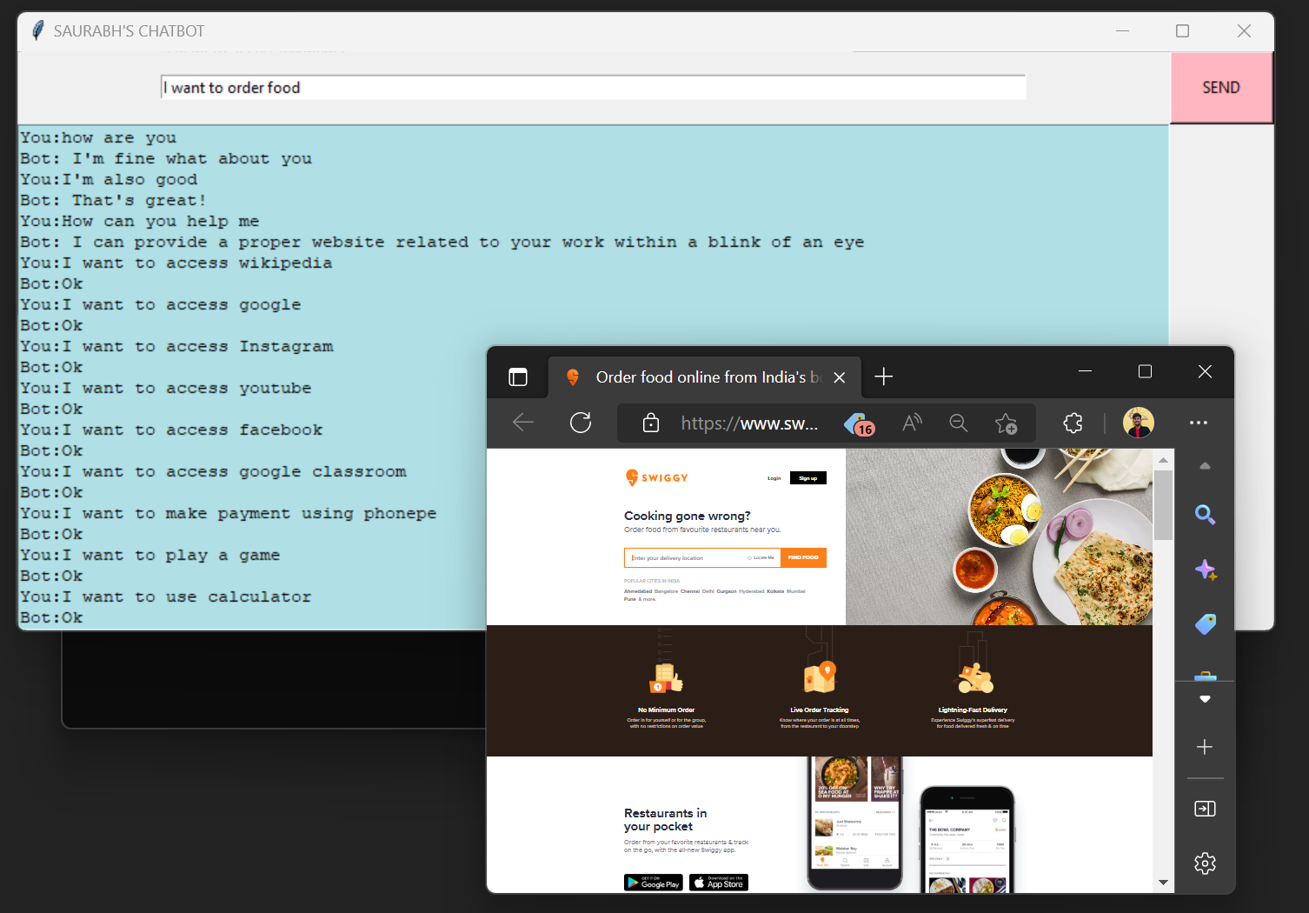

* 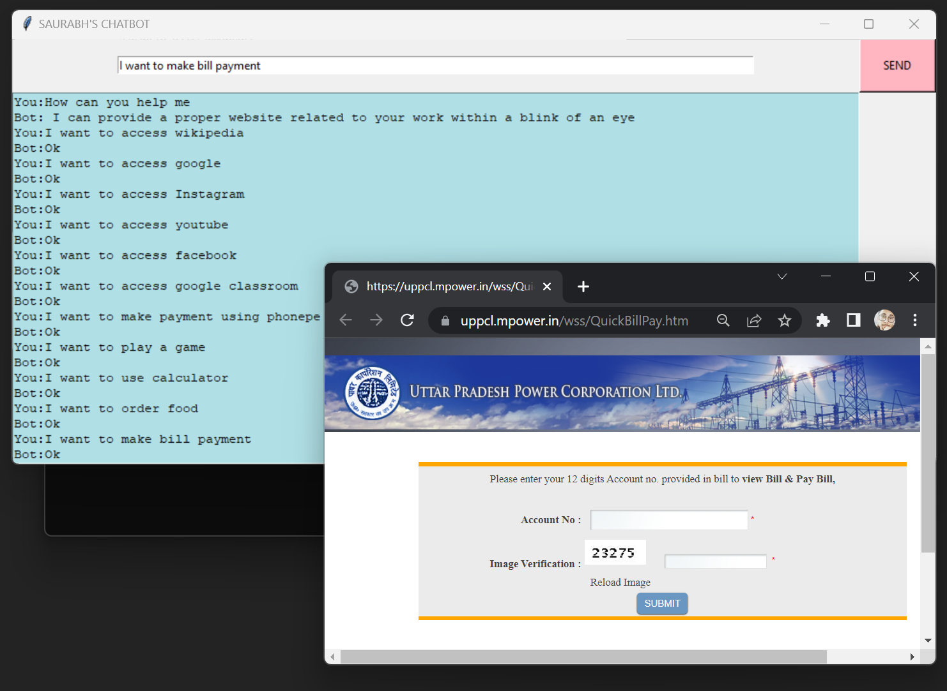Make Bill Payments
* Error Massage

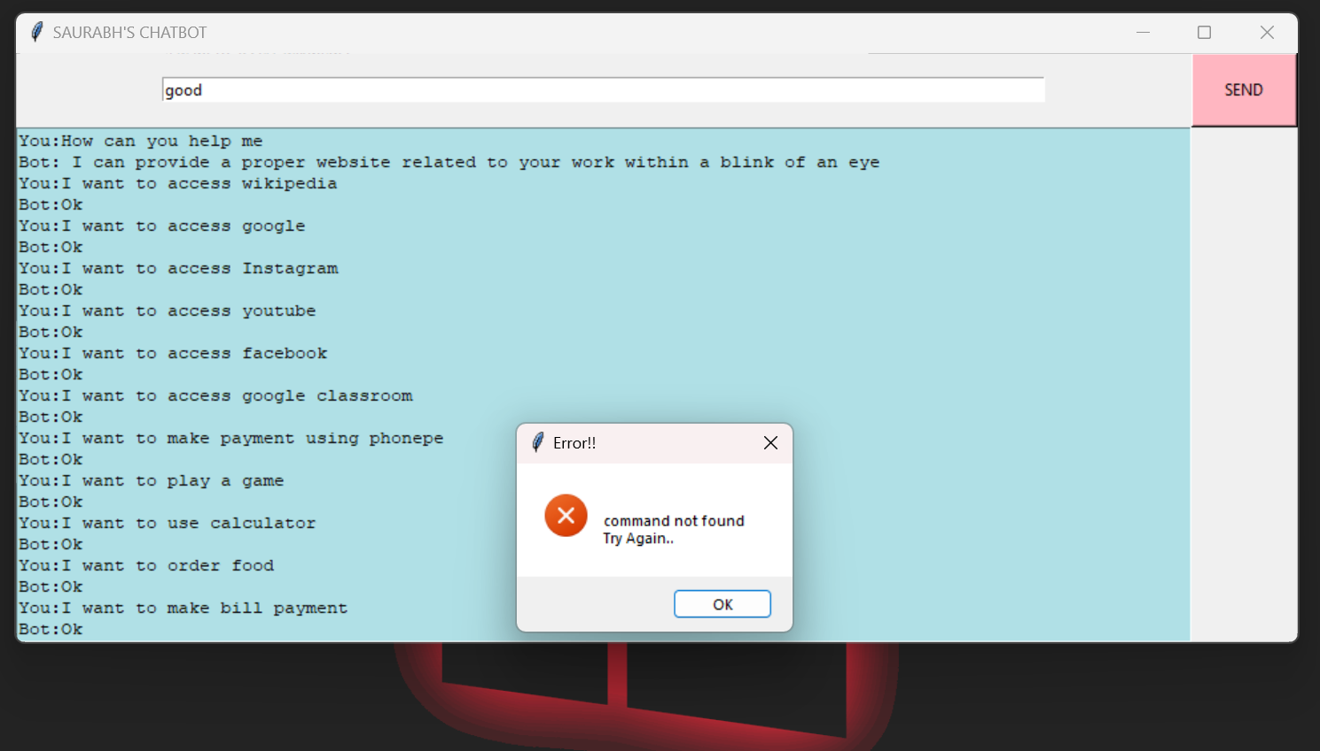

* End Massaging:

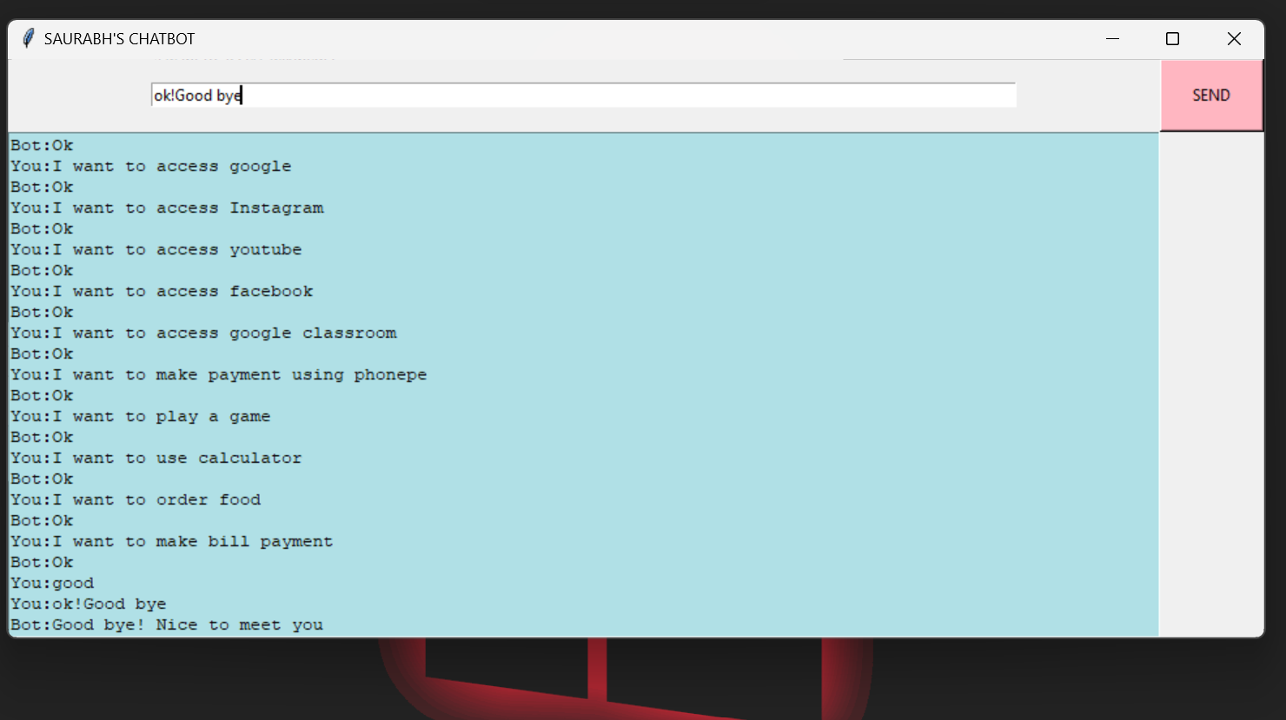

**CODE**

from tkinter import *

import webbrowser

from tkinter import messagebox

root = Tk()

def send():

    send = "You:" + e.get()

    text.insert(END, "\n" + send)

    if (e.get() == "hi"):

        text.insert(END, "\n" + "Bot: hello")

    elif (e.get() == "hello"):

        text.insert(END, "\n" + "Bot: hi")

    elif (e.get() == "how are you"):

        text.insert(END, "\n" + "Bot: I'm fine what about you")

    elif (e.get() == "I'm also good"):

        text.insert(END, "\n" + "Bot: That's great!")

    elif (e.get() == "How can you help me"):

        text.insert(

            END, "\n" + "Bot: I can provide a proper website related to your work within a blink of an eye")

    elif (e.get() == "ok!Good bye"):

        text.insert(END, "\n" + "Bot:Good bye! Nice to meet you")

    elif (e.get() == "I want to access wikipedia"):

        text.insert(END, "\n" + "Bot:Ok", webbrowser.open("wikipedia.com"))

    elif (e.get() == "I want to access google"):

        text.insert(END, "\n" + "Bot:Ok", webbrowser.open("google.com"))

    elif (e.get() == "I want to access Instagram"):

        text.insert(END, "\n" + "Bot:Ok", webbrowser.open("instagram.com"))

    elif (e.get() == "I want to access youtube"):

        text.insert(END, "\n" + "Bot:Ok", webbrowser.open("youtube.com"))

    elif (e.get() == "I want to access facebook"):

        text.insert(END, "\n" + "Bot:Ok", webbrowser.open("facebook.com"))

    elif (e.get() == "I want to access google classroom"):

        text.insert(END, "\n" + "Bot:Ok",

                    webbrowser.open("https://classroom.google.com/u/0"))

    elif (e.get() == "I want to make payment using phonepe"):

        text.insert(END, "\n" + "Bot:Ok", webbrowser.open("phonepe.com"))

    elif (e.get() == "I want to play a game"):

        text.insert(END, "\n" + "Bot:Ok", webbrowser.open("https://poki.com/"))

    elif (e.get() == "I want to use calculator"):

        text.insert(END, "\n" + "Bot:Ok",

                    webbrowser.open("online-calculator.com"))

    elif (e.get() == "I want to order food"):

        text.insert(END, "\n" + "Bot:Ok", webbrowser.open("Swiggy.com"))

    elif (e.get() == "I want to make bill payment"):

        text.insert(END, "\n" + "Bot:Ok", webbrowser.open(

            "https://uppcl.mpower.in/wss/QuickBillPay.htm"))

    else:

        messagebox.showerror(

            "Error!!", "\n " "command not found " " \n " "Try Again..")

text = Text(root, bg="Powder Blue", width=110)

text.grid(row=2, column=0, columnspan=1)

e = Entry(root, width=110)

send = Button(root, text="SEND", bg="light pink", width=10,

              height=3, command=send).grid(row=1, column=1)

e.grid(row=1, column=0)

root.title(" SAURABH'S CHATBOT ")

root.mainloop()

**References**

* www.code.visualstudio.com
* [www.wikipedia.com](http://www.wikipedia.com)
* www.chrome.com